MACH4METAL

metalworking machinery
Transito 21
6909 DA BABBERICH Netherlands
Tel. +31 (0)316-247123
Fax: +31 (0)316-247956
info@mach4metal.com
www.mach4metal.com

Bank No : 66.52.13.883
IBAN : NL33 INGB 0665 2138 83
BIC : INGBNL2A

HERKULES Profile bender BO
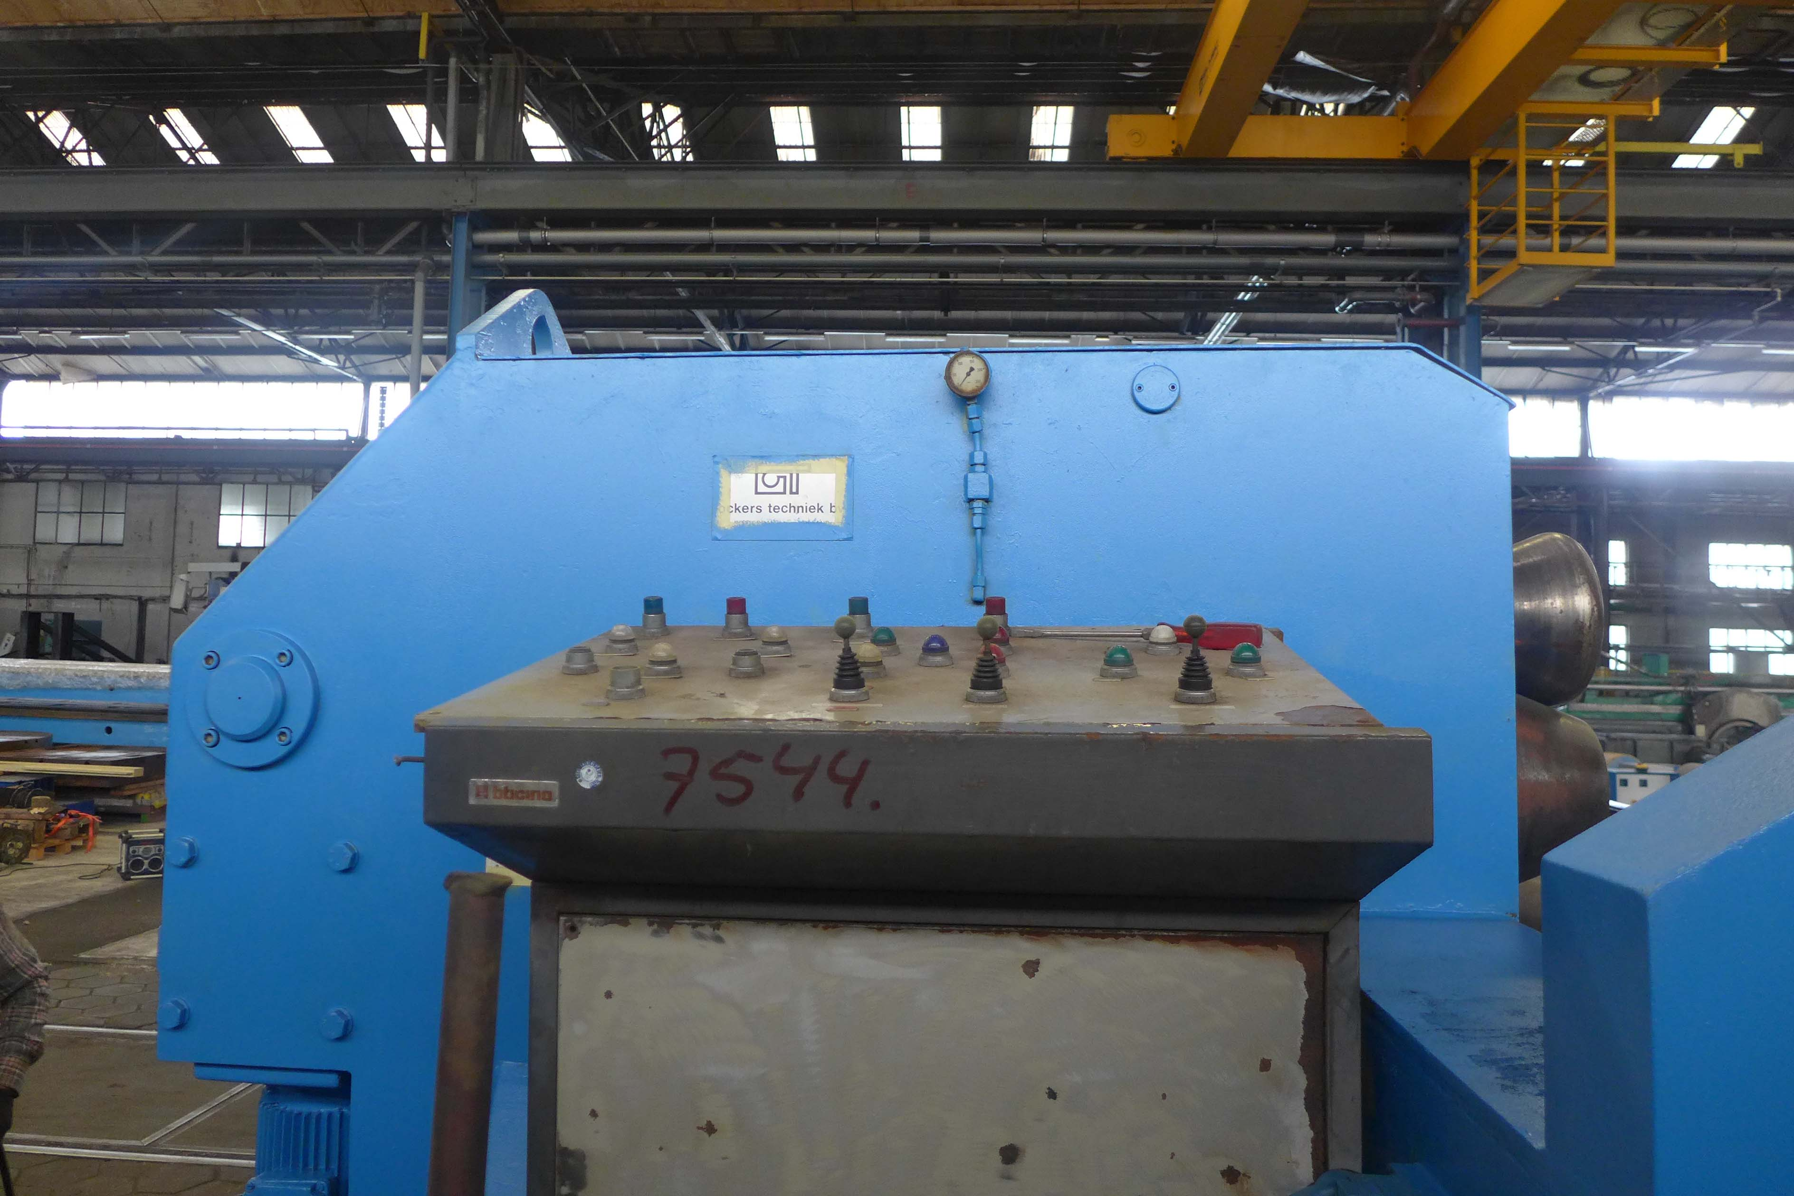
- Make : Herkules Wetzlar Germany
- Typ : BO 232 K
- Age : 60 / 70 er
- Serial : 6038

- Bending capacity
- Roll diameter Ø :
- Shaft diameter Ø :
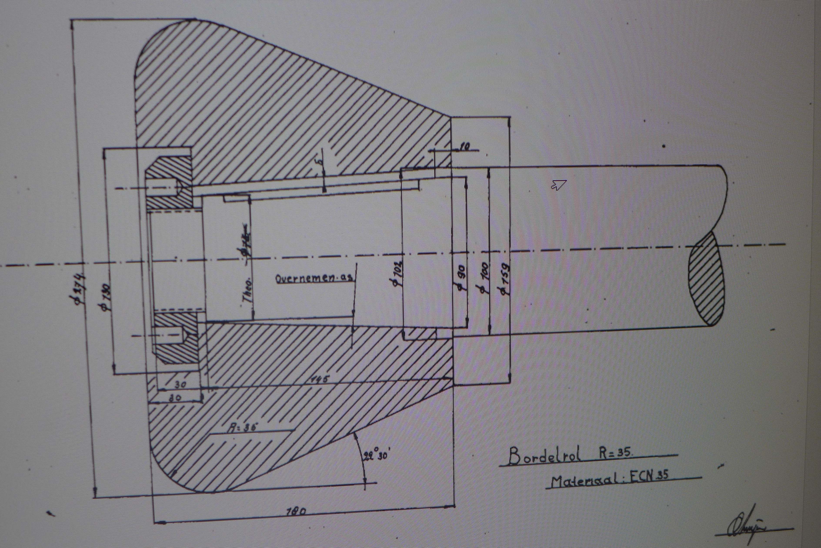
- Max. diameter : 5000 mm
- Travel stroke clamp : 2900 mm

- Ø 75
- Square 65 x 65
- T 120
- U 250
- I 240
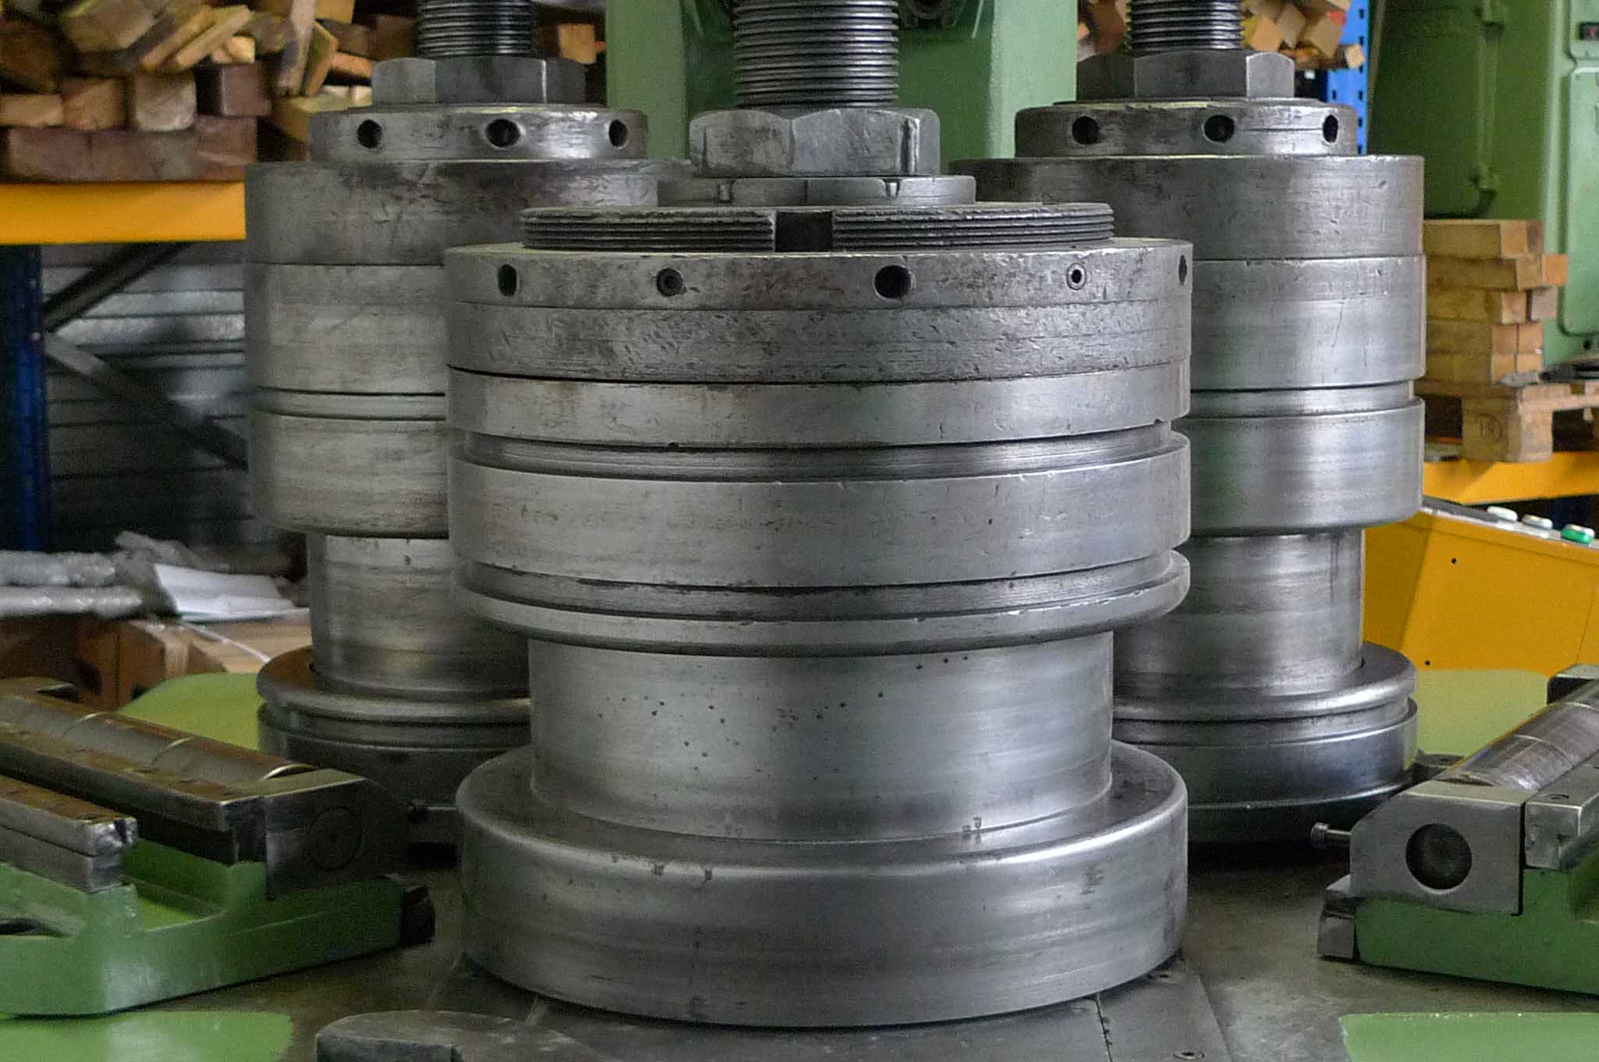

- Stroke off rolls 470 mm

- Shaft to shaft 450 mm
- Dimensions
- Length : 6000
- Width : 2650
- Height : 2800 / 4700
- Weight : 7500

Please Note: The above information has been obtained to the best of our ability and belief from, and from the manufacturers where possible. It is given in good faith, but its accuracy can not be guaranteed. Accordingly, it will not form a representation or constitute contractual terms. We advise you to check any vital details!

